**CO2 PROGRAMS**

**Program 1**

n=int(input('enter a number:'))

f=1

for i in range(1,n+1):

f=f*i

print('factorial of',n,'=',f)

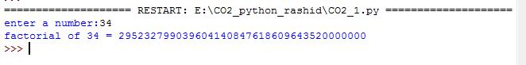

**Program 2**

n=int(input("enter the size "))

a=0

b=1

sum=0

count=1

print("fibonacci series is:",end=" ")

while(count<=n):

print(sum,end=" ")

count+=1

a=b

b=sum

sum=a+b

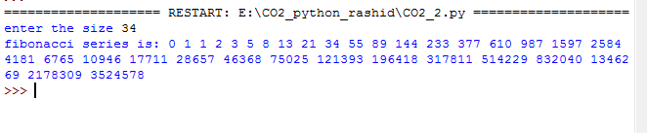

**Program 3**

l1=[10,15,20,25,30]

total=sum(l1)

print("the sum of the list is :",total)



**Program 4**

from math import sqrt as s

for i in range(1000,10000):

if s(i)==int(s(i)) and i%2==0:

print(i,end=" ")

**Program 5**

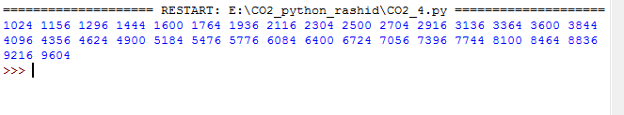

r=int(input("enter the number of rows"))

for i in range(1,r+1):

for j in range(1,i+1):

print(i*j,end=' ')

print()

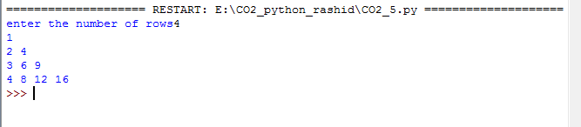

**Program 6**

test=str(input("enter the string"))

freq={}

for i in test:

if i in freq:

freq[i]+=1

else:

freq[i]=1

print("count of all characters:"+str(freq))

**Program 7**

str=input("enter a string")

print("inputed string is:",str)

if(str.endswith("ing")):

str=str+'iy'

else:

str=str+'ing'

print("the formatted string is:",str)

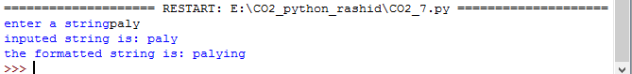

**Program 8**

a=[]

n=int(input("enter the number of element in list:"))

for x in range(0,n):

element=input("enter element"+str(x+1))

a.append(element)

max1=len(a[0])

temp=a[0]

for i in a:

if(len(i)>max1):

max1=len(i)

temp=i

print("longest word:",temp)

print("length of longest word:",max1)

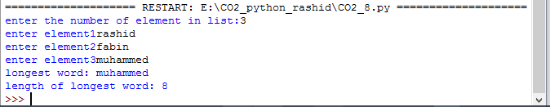

**Program 9**

n=int(input("Enter the limit:"))

for i in range(n):

for j in range(i):

print ('* ', end="")

print('')

for i in range(n,0,-1):

for j in range(i):

print('* ', end="")

print('')

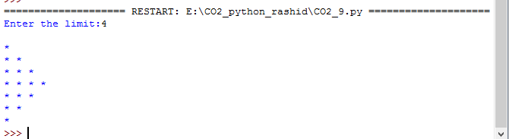

**Program 10**

def factors(x):

print("The factors of",x,"are:")

for i in range(1,x+1):

if x % i == 0:

print(i)

n=int(input("Enter a number:"))

factors(n)

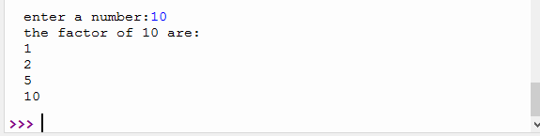

**Program 11**

import math

t_area=lambda b,h:1/2*b*h

r_area=lambda l,b:l*b

s_area=lambda a:a*a

print("Area of Triangle :",t_area(10,20))

print("Area of Rectangle:",r_area(30,20))

print("Area of Square :",s_area(15))

